# Lab 01: Microsoft Fabric Introduction

### 

### Introduction

The primary objective of this lab is to learn how to create a workspace, how to create a data warehouse, and lastly, you will do the installation of the OneLake file explorer for Windows, enabling you to view the data using OneLake explorer.

### Objectives

After completing this lab, you will be able to:

1. Create workspace, create a data warehouse
2. Install OneLake file explorer for Windows

**Estimated time to complete this lab**

45 minutes

Contents

Lab 01: Microsoft Fabric Introduction 1

Introduction 1

Objectives 1

Task 1: Create a workspace 3

Task 2: Create an Item (Data Warehouse) 4

Task 3: Install OneLake file explorer for Windows 6

**Lab Prerequisites**

* Workspace: Fabric, Power Premium or Fabric trial
* Individual license: Power Pro or Premium Per User account

**Information provided by your training provider**

* Trial tenant (if applicable): login & password, workspace to use for the lab.

### Task 1: Create a workspace

The workspace will contain all the Items\artifacts needed for data warehousing including data warehouse, datasets, and Power-BI reports etc.

1. Sign in to [Microsoft Fabric](https://app.fabric.microsoft.com/): <https://app.fabric.microsoft.com/>
2. Click on Synapse Data Warehouse

1. Select Workspaces > New Workspace.

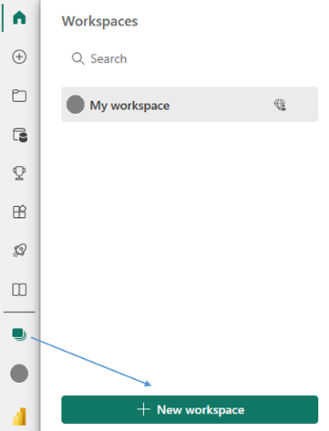

1. Fill out the Create a workspace form as follows:
   * + **Name:** Enter *WS_DW_Tutorial*, and some characters for uniqueness (for example, *WS_DW_Tutorial_name*)
     + **Description**: Optionally, enter a description for the workspace.

1. Expand the Advanced section.
2. Choose Premium capacity in the License Mode section.

Choose a premium capacity if you have access to it.

1. Select Apply. The workspace will be created and opened.

### Task 2: Create an Item (Data Warehouse)

The intent of this section is to quickly build a data warehouse item in the above “WS_DW_Tutorial” Workspace.

***Note***: You should use the workspace name you created above. In this doc we will refer to the name as “WS_DW_Tutorial”.

1. In the [Microsoft Fabric](https://app.fabric.microsoft.com/)select Workspaces in the left-hand menu.
2. Search for the workspace you created “WS_DW_Tutorial” in Task 1 by typing in the search textbox at the top and click on your workspace to open it.

1. In the upper left corner, select New > Click “More Options” to show a full list of available items.

1. In the Data Warehouse section> select Warehouse

1. On the New warehouse dialog, enter DW_WH01 as the name > Select Create

1. When provisioning is complete the **Build a warehouse** landing page will be shown.

### Task 3: Install OneLake file explorer for Windows

The intent of this section is to install OneLake file explorer for Windows so that you can explore the data using OneLake explorer from your PC.

1. Download the OneLake file explorer: <https://www.microsoft.com/en-us/download/details.aspx?id=105222>
2. Begin the installation process by double-clicking the file.
3. Click on the install.

1. Sign-in using your ADD Click on the install.

1. Once you login successfully, you will see OneLake Explorer on your machine.

You can click on your workspace and see as a folder all the artifacts in your workspace.

For example, in the picture below there are 2 Datawarehouse and 1 Lakehouse:

In the next lab, you will create tables and you will see that the tables will also be a folder and the data is stored as Parquet files:

This is the end of the lab. Congratulations for finishing the lab!